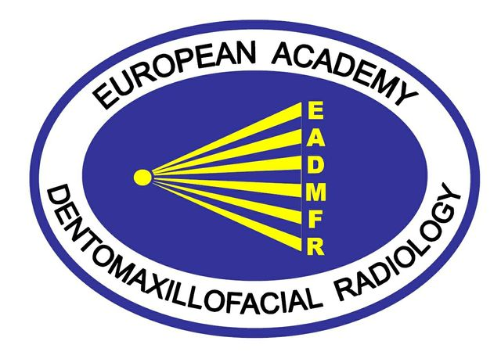

EADMFR 6th junior meeting
Istanbul 3-7 February 2019

Date | Time | Group |  | Subject | Lecturer
Sunday 3 February
19.00-22.00
Get-together
Venue: Hilton Garden Inn Hotel
Monday 4 February
Venue: Hilton Garden Inn Hotel
Mon 6/2 | 09.00-10.00  10.00-10.45  10.45-11.00  11.00-12.00  12.00-13.30  13.30-15.00  15.00-15.30  15.30- 17.00 |  | all | Introduction of participants and program  Radiation dose from DMFR  Coffe break  Evidence based radiology (EBR)  Introduction EBR task  Lunch  Work in small groups with EBR task  Coffee break  Continues work with EBR tasks | Linda Arvidsson  Ingrid Rózylo-Kalinowska  İbrahi Sevki Bayraktar (Local Host)  junior committee  Dennis Rottke  Christina Lindh
19.00
Dinner
Presentation EADMFR
Ingrid Rózylo-Kalinowska, president
Junior committee
Venue: Hilton Garden Inn Hotel
Tuesday 5 February
Venue: Hilton Garden Inn Hotel
Tue 9/2 | 09.00-10.00  10.00-11.00  11.00-11.30  11.30-13.00  13.00-14.30  14.30-17.30 | all |  | Ultrasound in Head and Neck  TMJ  Coffee break  Presentation DMFR programs in EU  1. xxxx  2. xxxx  3- xxxx  Presentation of scientific work  1. xxx  2. xxx  3. xxxx  Lunch  Work in three groups:  A. Ultrasound hands-on  B. PR and CBCT hands-on  C. Oral and pharyngeal function | Rose Ngu  Ingrid Rózylo-Kalinowska  Linda Arvidsson  Selected participants  Ingrid Rózylo-Kalinowska  Rose Ngu  Kaan Orhan, Dennis Rottke  Eva Levring Jäghagen
Evening free
JC com. dinner

Wednesday 6 February
Venue: Hilton Garden Inn Hotel
Wed 10/2 | 09.00-10.30  10.30-11.00  11.00-12.30  12.30-13.30  13.30-15.00  15.00-15.30  15.30-16.30 | all |  | Presentation of scientific work  1. xxxxx  2. xxxxx  3. xxxxx  4. xxxxx  5. xxxxxx  6. xxxxx  7. xxxxx  Coffee break  Presentation of EBR tasks  Lunch  Diploma test-  Coffee break  Evaluation | Selected participants  All participants  Francois Gabioud/Marius Bud  Linda Arvidsson  Junior committee
17:00-20:00 Panoramic City Tour (Old Town)
Dinner : Taksim Sultanas Resturant with Belly Dance Show
After Party Venue: Venue to be decided (Club)

